Index No. _________

MILITARY COLLEGE OF SIGNALS
FINAL EXAMINATION – Multivariable Calculus
(BESE – 15)

Instructor: Dr Saeed Murtaza Date: November 06, 2010.
Max Time: 150 min Max Marks: 30

Note
- Attempt all questions in the given sequence.
- Understanding question is the part of examination.
- Show complete working, i.e., do not miss any point in your solution and do not leave any thing for the instructor to assume on your behalf.
- There are no marks for the procedure only.
- Attach question paper with the answer sheet.

Q. No. 1:
In your opinion what should be the role of a professional engineer in society and how mathematics can help in regard?
[3]
Q. No. 2:
What are the two most important differences between the Ordinary and Partial Differential Equations?
[3]
Q. No. 3:
In order to find the solution of a 2nd order homogenous linear ordinary differential, e.g., 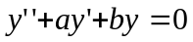, we assume that 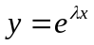is a solution. Justify this assumption. i.e., why we don’t assume that any other function could be a solution.
[3]
Q. No. 4:
Find out the particular solution of:
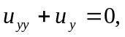if 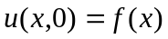and 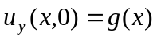
[5]
Q. No. 5:
Draw a sketch of initial deflection and find the deflection 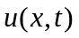of the string of length L = 10 cm when c = 1, the initial velocity is zero, and the initial deflection is =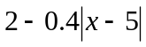.
[3+5]

P.T.O
Q. No. 6:
Derive one dimensional “Heat Equation” 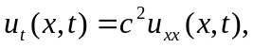 where 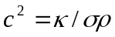 is thermal diffusivity.
[4]
Q. No. 7:
The boundary condition of heat transfer 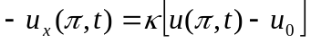applies when a bar of length with c = 1 is laterally insulated, the left end  is kept at 0ºC, and at the right end heat is flowing into air of constant temperature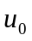. Let 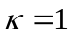, for simplicity, and 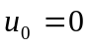. Show that a solution is 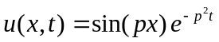, subject to the condition 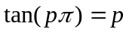.
[4]

